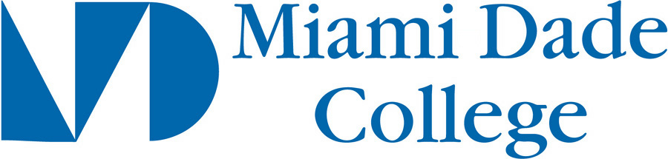
Transfer Planning Guide:
Recommendation Request Guidelines

In addition to your preparing your transfer application packages, there will be opportunities for you to apply for scholarships, internships and special programs that require letters of recommendation.

Instructors, other College personnel, internship supervisors want to write recommendations for you. To help them prepare the best possible letters for you, we strongly suggest that you ask them:

- how they would prefer to receive the Letter of Recommendation Request (via email or hard copy). Provide it to the recommender in his/her preferred format
- if you can pick the letter up or if they would prefer to mail it directly
- which email you should provide to the institution or agency if the recommendation must be completed online
- if they require any additional documentation
- if they would like to meet with the you to discuss your academic progress, goals, accomplishments and any other important points that they might refer to in this letter

Always keep the following guidelines in mind when asking for letters of recommendation:

- It’s perfectly acceptable to ask several instructors/individuals for recommendations then choose the best or most appropriate ones that meet your purposes (if they are willing to give it to you to read).
- Politely request a letter of recommendation; never say: “I need a letter…”
- Ask your instructors/individuals how much time they need to complete your letter and what is their availability; don’t give them any last-minute surprises such as “I need this immediately” (= bad on two counts, right?)
- Only ask for recommendations from instructors/individuals who know you well enough to write a strong letter for you. Ask those who know you because you participate in class discussions, meet with them to discuss the course or other issues, and/or participate in extracurricular activities with which the instructors/individuals are familiar.
- Be sure to thank the instructors/individuals and let them know if/when you receive any notification about your acceptance, hiring, scholarship, etc. They like to know about your successes.

Be sure to provide them with the following (if requested):
- a current MDC degree audit (highlight the courses you’ve taken with the instructor you are asking to provide the reference)
- a current service-learning transcript (if you have done any service during your time at MDC)
- any forms or letter guidelines
- stamped, addressed envelopes if they have to mail the letters separately from your application.

Take the opportunity and complete the form below when asking the instructor/individual for the recommendation to facilitate the process. The length of your responses is up to you but the more specific and relevant things you present, the more comprehensive the letter can potentially be. Proofread carefully.

MDC Letter of Recommendation Request Form

Please attach
- a recent, unofficial copy of your transcript or degree audit (highlight all courses you’ve taken with the instructor whom you’ve asked for a recommendation; expand all the categories if you print this from the Web)
- a MDC service-learning transcript (only if you’ve done any service-learning at MDC and have documented it through iCED)
- a print copy of guidelines for the scholarship / internship / award / (if applicable)

Student's  First Name: | Student’s  Last Name: | MDC Student #:
Address: | City: | State: Zip code:
Phone #: | E-mail: | Major:
Current Cumulative GPA: | Number of credits earned to date: | Expected date of graduation:
Name(s) of Scholarship / Internship / Award:

Planning to transfer? List all schools you are applying to for transfer. Space below will expand as you type.
NOTE: Attach any recommendation forms not on the Common App along with a stamped, typed-address envelope for that recommendation if it must by mailed by this recommender.

What is the deadline(s) you must meet? (provide at least two weeks advance request):

Type your responses to all the questions (use these questions as your section headers; space will expand).

- What is unique or special about you that distinguish you from other students?
- How would you describe yourself? Why?
- How would faculty other than I describe you? Why?
- How did you distinguish yourself in my class(es)? i.e. cite specific examples of how you are/were consistently committed to academic excellence and enthusiastic about learning.
- How have you shared what you have learned with others (in / outside of formal classroom / lab settings)?
- What are your strengths and how have you applied these to your studies?
- How have you demonstrated your enthusiasm for learning (inside or outside of the classroom/lab)?
- Describe any life (academic / health / workplace / spiritual / relationship / etc.) challenges you have overcome that speak to your character and / or determination.
- Describe any leadership roles you have taken in class / lab, in service-learning, and / or in co/extracurricular activities that I would know about or that I would have seen you “in action”.
- What have you learned about yourself while attending MDC?
- What have you learned from your service-learning experiences while at MDC? (if applicable)
- List your hobbies and non-academic interests (particularly as they relate to your career interests). What are you particularly passionate about?
- What are your career goals? What would you like to do after graduation with a baccalaureate degree?
- Are you currently working / interning? How many hours per week (on average)? What do you do?
- For scholarship recommendation letters only: What are the scholarship's qualification requirements and how do you qualify?

